Dokumentacja projektu z C#

Wykonal:Taras Kuts 16555

W projekcie jest realizowane następne:
Histogram RGB/Grayscale,przeksztalcenia w grayscale,nakladanie róznych masek około 18 oraz możliwość nakladania wlasnej,scalowanie,nakladanie pikselow brzygowych,
rozciągnięcia histogramu z wartosciami Min i Max,Treshhold z wartościami Min i Max,redukcjia z parametrami qi,pi,Treshhold z jedną wartościu,dilacja,erozja,opening,closing,negacja,compression za algorytmama Read,code Huffmana i Compression with parametres,equalizing and stratching,mediana różne rozmiary z opcja nakladania od razu pikselej brzygowych.Też operacje na dwoch obrazach taki jak ADD,DIFF,SUB,OR,XOR,AND.Dla nakladanie dilacji,erozji,opening i closing jest wykorzystana biblioteka Aforge.
Przykladowe działanie programy:
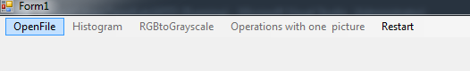
Przy starcie programy

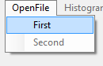
Mozemy tylko nacisnąć OpenFile lub Restart.First to jest pierwszyj obraz

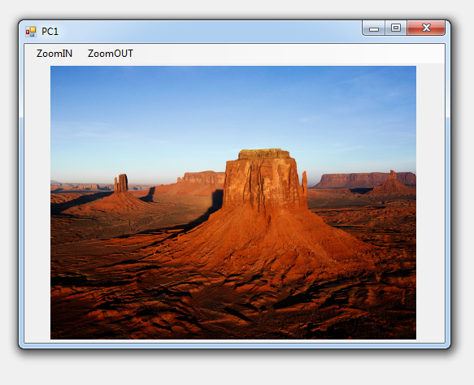

Możemy ten obraz zwiększyć lub zmniejszyć.Dalej widzimy że możemy już używać RGBtoGraysclafe-Picture1 lub Histogram-RGB
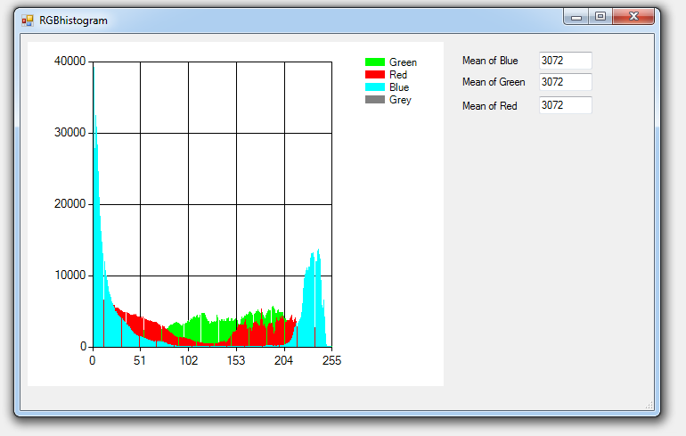
Po grayscale możemy już działać z obrazem.
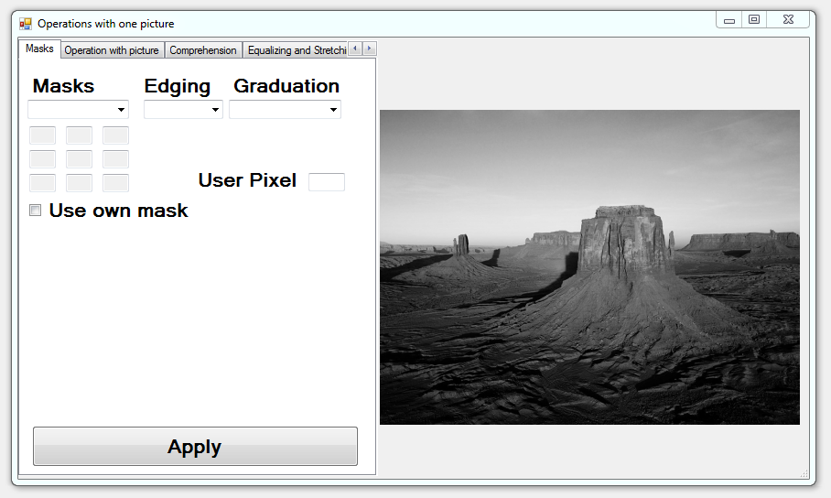
Odrazu mamy przeksztalcony obraz w grayscali jake po nacisniecu na go mozemy Zmniejszyc/Zblizac lub Save.
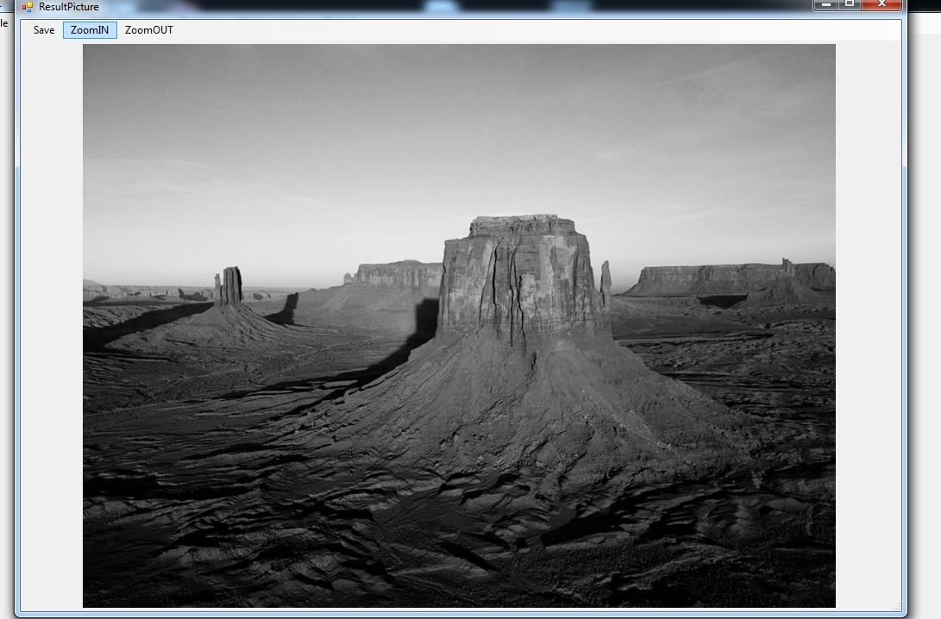

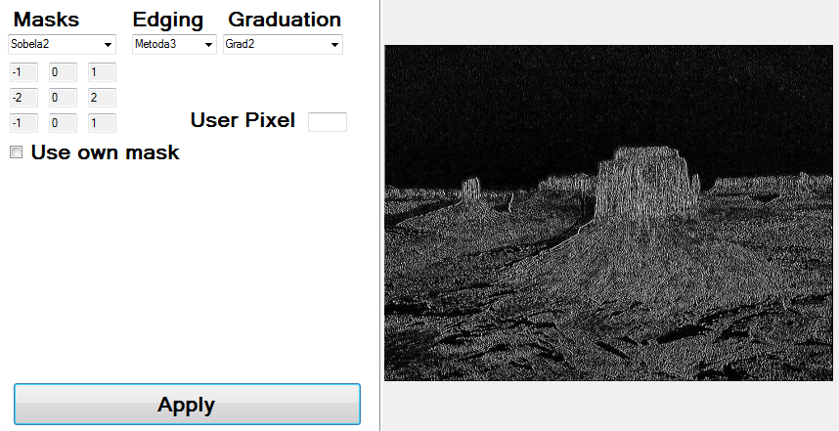
Po naciśnięciu Use own mask możemy wpisywać wlasną maske.
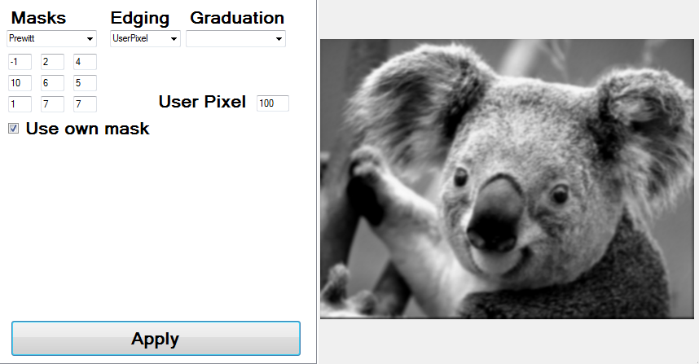

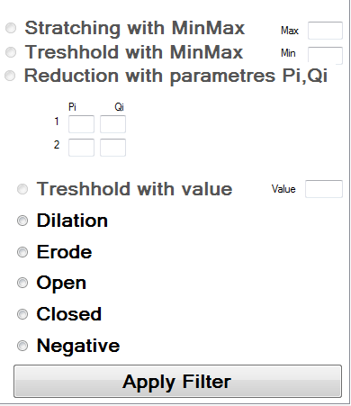
Stratching with MinMax,Treshhold with MinMax,Reduction with parametres Pi,Qi i Treshhold with value mozemy wybrac odpowiednie kiedy wpiszemy wartosci w kazde pole odpowiednie.

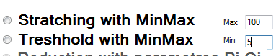

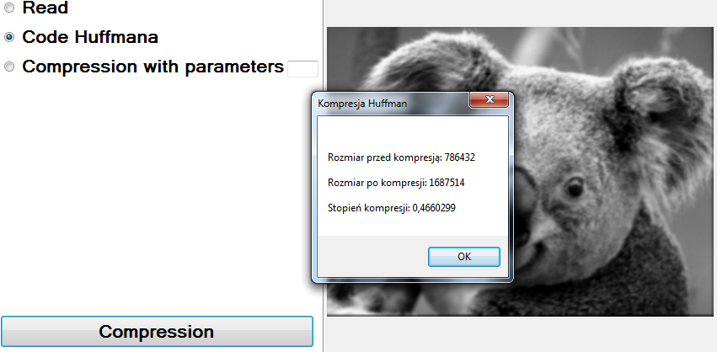
Mozemy zapisac i zobaczyc ze obraz był skompersowany.
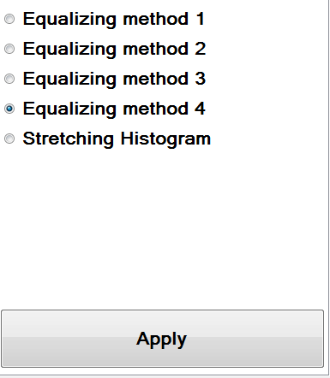
Wybieramy naciskamy „Apply”

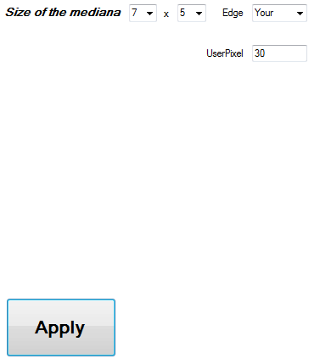

Zeby można było nacisnac operation with two pictures trzeba utworzyc jeszcze jedna i zrobic w graysclae wtydy jest już dostepna mozliwosc dzialania z ta opcja.
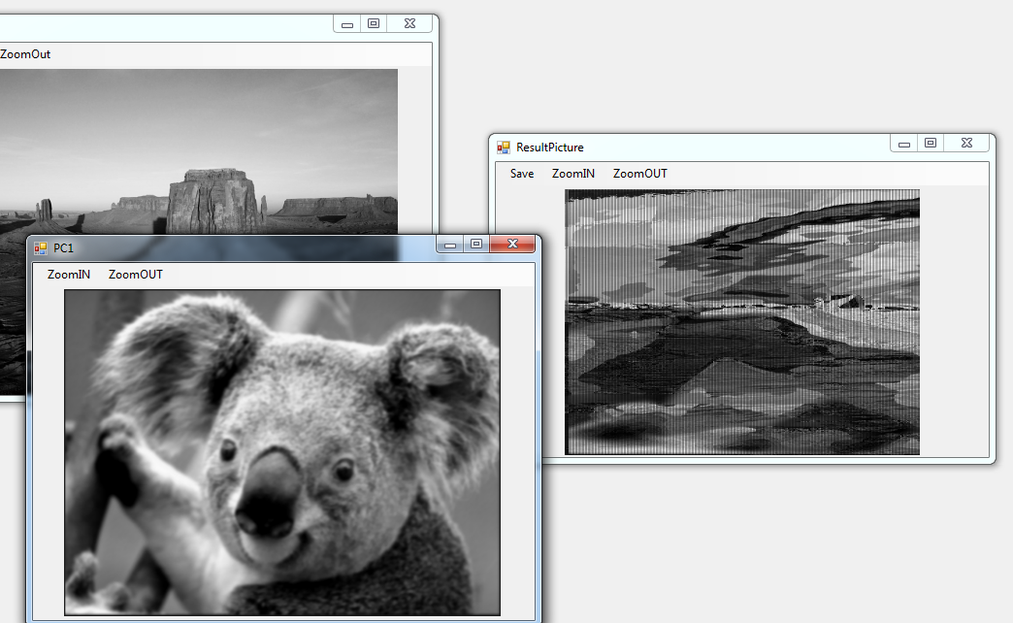
Wynik peracji XOR , wynik możemy zapisać.
Kod:Class ImageManipulation

using AForge.Imaging.Filters;
using System;
using System.Collections.Generic;
using System.Drawing;
using System.Drawing.Imaging;
using System.Linq;
using System.Runtime.InteropServices;
using System.Text;
using System.Threading.Tasks;
using System.Windows.Forms;

namespace Csharp
{
enum Graduation { first, second, third };
enum maskSize { three = 0, five = 1, seven = 2 };
enum edgeMethods { first, second, third, mine };
enum masksAplied { onNine, onTen, onSixteen, cyfrowaLaplas, laplasA, laplasB, laplasC, laplasD, edgeOne, edgeTwo, edgeThree, Roberts, Roberts2, Prewitt, Prewitt2, Uniwersal1, Uniwersal }
enum equalizationsMetods { metoda1, metoda2, metoda3, metoda4 };
enum ArithmeticOperations { ADD, SUB, DIFF, OR, AND, XOR };
enum Histogram { HistogramRGB, Histogram };
class ImageManipulation
{
public Bitmap imgBitmapCOPY { set; get; }
public Bitmap imgBitmap2 { set; get; }
public Bitmap imgBitMap { set; get; }
public List<long[]> ListOfHistogramGrey = new List<long[]>();
public List<long[]> ListOfHistogramRGB = new List<long[]>();
long[] histogramBlue = new long[256];
long[] histogramRed = new long[256];
long[] histogramGreen = new long[256];
long[] histogramGray = new long[256];
int min = 255;
int max = 0;
static int levels = 256;
public double histogramAVG { get; set; }
private static object imageLocker = new object();
void Temp(out BitmapData bmData, out int bytesPerPixel, out int heightInPixels, out int widthInPixels)//zeby kazdy raz nie pisac
{
bmData = imgBitMap.LockBits(new Rectangle(0, 0, imgBitMap.Width, imgBitMap.Height), ImageLockMode.ReadOnly, imgBitMap.PixelFormat);
bytesPerPixel = Bitmap.GetPixelFormatSize(imgBitMap.PixelFormat) / 8;
heightInPixels = imgBitMap.Height;
widthInPixels = imgBitMap.Width * bytesPerPixel;
}
public ImageManipulation(Bitmap imgBitmap)
{
this.imgBitMap = imgBitmap;
this.imgBitmapCOPY = imgBitmap;

}
public byte GetPixel(int x, int y, BitmapData bmpData)
{
unsafe
{
byte* ptr = (byte*)((byte*)bmpData.Scan0 + (y * bmpData.Stride) + x);
return *ptr;
}
}
public void SetPixel(int x, int y, BitmapData bmpData, byte value)
{
unsafe
{
byte* ptr = (byte*)((byte*)bmpData.Scan0 + (y * bmpData.Stride) + x);
*ptr = value;
}
}
public void MaskOnImage(int[,] maskArray, uint K)
{
Convolution applyMask = new Convolution(maskArray, (int)K);
applyMask.ApplyInPlace(imgBitMap);
}
public void MaskOnImage(int[,] maskArray)
{
Convolution applyMask = new Convolution(maskArray);
applyMask.ApplyInPlace(imgBitMap);
}
public void StratchingRang(int Max, int Min)
{
BitmapData bmData = null;
int bytesPerPixel, heightInPixels, widthInPixels;
try
{
Temp(out bmData, out bytesPerPixel, out heightInPixels, out widthInPixels);
for (int y = 0; y < heightInPixels; y++)
{

for (int x = 0; x < widthInPixels; x += bytesPerPixel)
{
if (Min <= GetPixel(x, y, bmData) && Max >= GetPixel(x, y, bmData))
{
SetPixel(x, y, bmData, (byte)((GetPixel(x, y, bmData) - Min) * (15 / (Max - Min))));
}
if (GetPixel(x, y, bmData) <= Min && GetPixel(x, y, bmData) > Max)
{
SetPixel(x, y, bmData, 0);
}
}
}
imgBitMap.UnlockBits(bmData);
}
catch
{
try
{
imgBitMap.UnlockBits(bmData);
throw new Exception("Some problem in StratchingRange func");
}
catch
{
throw new Exception("Some problem in StratchingRange func");
}
}
}
public void Redukcja(int pi1, int pi2, int q1, int q2)
{
BitmapData bmData = null;
int bytesPerPixel, heightInPixels, widthInPixels;
try
{
Temp(out bmData, out bytesPerPixel, out heightInPixels, out widthInPixels);
for (int y = 0; y < heightInPixels; y++)
{
for (int x = 0; x < widthInPixels; x += bytesPerPixel)
{
if (GetPixel(x, y, bmData) <= pi1)
SetPixel(x, y, bmData, (byte)q1);
else if (GetPixel(x, y, bmData) > pi1 && GetPixel(x, y, bmData) <= pi2)
{
SetPixel(x, y, bmData, (byte)q2);
}
else
{
SetPixel(x, y, bmData, (byte)levels);
}
}
}
imgBitMap.UnlockBits(bmData);
}
catch
{
try
{
imgBitMap.UnlockBits(bmData);
throw new Exception("Some problem in Redukcja func");
}
catch
{
throw new Exception("Some problem in Redukcja func");
}
}
}
public void TresholdMinMax(int Max, int Min)
{

BitmapData bmData = null;
int bytesPerPixel, heightInPixels, widthInPixels;
try
{
Temp(out bmData, out bytesPerPixel, out heightInPixels, out widthInPixels);
for (int y = 0; y < heightInPixels; y++)
{
for (int x = 0; x < widthInPixels; x += bytesPerPixel)
{
if (GetPixel(x, y, bmData) < Min || GetPixel(x, y, bmData) > Max)
{
SetPixel(x, y, bmData, 0);
}
}
}
imgBitMap.UnlockBits(bmData);
}
catch
{
try
{
imgBitMap.UnlockBits(bmData);
throw new Exception("Some problem in TreshholdMinMax func");
}
catch
{
throw new Exception("Some problem in TreshholdMinMax func");
}
}

}
public void Treshold(int CurTresh)
{
BitmapData bmData = null;
int bytesPerPixel, heightInPixels, widthInPixels;
try
{
Temp(out bmData, out bytesPerPixel, out heightInPixels, out widthInPixels);
for (int y = 0; y < heightInPixels; y++)
{
for (int x = 0; x < widthInPixels; x += bytesPerPixel)
{
if (GetPixel(x, y, bmData) < CurTresh)
SetPixel(x, y, bmData, 0);
else
SetPixel(x, y, bmData, 255);
}
}

imgBitMap.UnlockBits(bmData);
}
catch
{
try
{
imgBitMap.UnlockBits(bmData);
throw new Exception("Some problem in Treshhold func");
}
catch
{
throw new Exception("Some problem in Treshhold func");
}
}

}
public void GetHistogram(Histogram histogramy)
{
BitmapData bmData = null;
int bytesPerPixel, heightInPixels, widthInPixels;
try
{
Temp(out bmData, out bytesPerPixel, out heightInPixels, out widthInPixels);
System.IntPtr Scan0 = bmData.Scan0;
unsafe
{
byte* ptrFirstPixel = (byte*)(void*)Scan0;
for (int y = 0; y < heightInPixels; y++)
{
byte* currentLine = ptrFirstPixel + (y * bmData.Stride);
for (int x = 0; x < widthInPixels; x += bytesPerPixel)
{
switch (histogramy)
{
case Histogram.HistogramRGB:
histogramBlue[currentLine[x]]++;
histogramGreen[currentLine[x + 1]]++;
histogramRed[currentLine[x + 2]]++;
break;
case Histogram.Histogram:
histogramGray[currentLine[x]]++;
break;
}
}
}
}
imgBitMap.UnlockBits(bmData);
}
catch
{
try
{
imgBitMap.UnlockBits(bmData);
throw new Exception("Some problem in Histogram func");
}
catch
{
throw new Exception("Some problem in Histogram func");
}
}
ListOfHistogramGrey.Add(histogramGray);
ListOfHistogramRGB.Add(histogramBlue);
ListOfHistogramRGB.Add(histogramRed);
ListOfHistogramRGB.Add(histogramGreen);
}
public MinMaxAveragePixel MaxMinPixelsMeth()
{
BitmapData bmData = null;
MinMaxAveragePixel MinMaxAverage = new MinMaxAveragePixel();
int bytesPerPixel, heightInPixels, widthInPixels;
try
{
Temp(out bmData, out bytesPerPixel, out heightInPixels, out widthInPixels);
for (int y = 0; y < heightInPixels; y++)
{
for (int x = 0; x < widthInPixels; x += bytesPerPixel)
{
MinMaxAverage.max = Math.Max(MinMaxAverage.max, GetPixel(x,y,bmData));
MinMaxAverage.min = Math.Min(MinMaxAverage.min, GetPixel(x,y,bmData));
}
}
MinMaxAverage.averageG = histogramGreen.Average();
MinMaxAverage.averageB = histogramBlue.Average();
MinMaxAverage.averageR = histogramRed.Average();
MinMaxAverage.averageGrayscale = histogramGray.Average();
imgBitMap.UnlockBits(bmData);
}
catch
{
try
{
imgBitMap.UnlockBits(bmData);
throw new Exception("Some problem in MinMaxAverage func");
}
catch
{
throw new Exception("Some problem in MinMaxAverage func");
}
}
return MinMaxAverage;
}
public unsafe Bitmap Negate(Bitmap originalImage)
{
Bitmap finalImage = new Bitmap(
originalImage.Width,
originalImage.Height,
PixelFormat.Format24bppRgb);

lock (imageLocker)
{
BitmapData originalImageData = originalImage.LockBits(
new Rectangle(0, 0, finalImage.Width, finalImage.Height),
ImageLockMode.ReadOnly,
PixelFormat.Format24bppRgb);

BitmapData finalImageData = finalImage.LockBits(
new Rectangle(0, 0, finalImage.Width, finalImage.Height),
ImageLockMode.WriteOnly,
PixelFormat.Format24bppRgb);

int originalImageRemain = originalImageData.Stride - originalImageData.Width * 3;
int finalImageRemain = finalImageData.Stride - finalImageData.Width * 3;

byte* originalImagePointer = (byte*)originalImageData.Scan0.ToPointer();
byte* finalImagePointer = (byte*)finalImageData.Scan0.ToPointer();

for (int i = 0; i < originalImage.Height; ++i)
{
for (int j = 0; j < originalImage.Width; ++j)
{
finalImagePointer[2] = (byte)(255 - originalImagePointer[2]);
finalImagePointer[1] = (byte)(255 - originalImagePointer[1]);
finalImagePointer[0] = (byte)(255 - originalImagePointer[0]);
originalImagePointer += 3;
finalImagePointer += 3;
}
originalImagePointer += originalImageRemain;
finalImagePointer += finalImageRemain;
}
imgBitMap.UnlockBits(originalImageData);
finalImage.UnlockBits(finalImageData);
}

return finalImage;
}
public unsafe Bitmap ConvertToGrayScale(Bitmap originalImage)
{
Bitmap finalImage = new Bitmap(
originalImage.Width,
originalImage.Height,
PixelFormat.Format8bppIndexed);

//setting up a nice grayscale palette for a final image
ColorPalette colorPalette = finalImage.Palette;
for (int i = 0; i < 256; ++i)
colorPalette.Entries[i] = Color.FromArgb(i, i, i);
finalImage.Palette = colorPalette;

lock (imageLocker)
{
BitmapData originalImageData = originalImage.LockBits(
new Rectangle(0, 0, originalImage.Width, originalImage.Height),
ImageLockMode.ReadOnly,
PixelFormat.Format24bppRgb);

BitmapData finalImageData = finalImage.LockBits(
new Rectangle(0, 0, finalImage.Width, finalImage.Height),
ImageLockMode.WriteOnly,
PixelFormat.Format8bppIndexed);

//getting number of bits which are used for pad the bitmap
int originalImageRemain = originalImageData.Stride - originalImageData.Width * 3;
int finalImageRemain = finalImageData.Stride - finalImageData.Width;

//getting the pointers
byte* originalImagePointer = (byte*)originalImageData.Scan0.ToPointer();
byte* finalImagePointer = (byte*)finalImageData.Scan0.ToPointer();

for (int i = 0; i < originalImage.Height; ++i)
{
for (int j = 0; j < originalImage.Width; ++j)
{
byte gray = (byte)(originalImagePointer[2] * 0.2989 +
originalImagePointer[1] * 0.5870 +
originalImagePointer[0] * 0.1140);

finalImagePointer[0] = gray;

originalImagePointer += 3;
finalImagePointer += 1;
}
originalImagePointer += originalImageRemain;
finalImagePointer += finalImageRemain;
}
originalImage.UnlockBits(originalImageData);
finalImage.UnlockBits(finalImageData);
}

return finalImage;
}
public void equalizingHistogram(equalizationsMetods Metody)
{
double[] NEW = new double[256];
long[] Right = new long[256];
long[] Left = new long[256];
int R = 0;
long H = 0;
BitmapData bmData = null;
histogramAVG = histogramGray.Average();
//double[] histogramGray = new double[256];
int bytesPerPixel, heightInPixels, widthInPixels;
Temp(out bmData, out bytesPerPixel, out heightInPixels, out widthInPixels);
System.IntPtr Scan0 = bmData.Scan0;
for (int z = 0; z <= 255; ++z)
{
Left[z] = Right[z];
H += histogramGray[z];
while (H > histogramAVG)
{
H -= (int)histogramAVG;
R++;
}
Right[z] = R;
switch (Metody)
{
case equalizationsMetods.metoda1:
NEW[z] = (Right[z] + Left[z]) / 2;
break;
case equalizationsMetods.metoda2:
NEW[z] = (Right[z] - Left[z]);
break;
case equalizationsMetods.metoda4:
NEW[z] = (Right[z] + Left[z] / 2) + (Right[z] / 2);
break;
default:
break;
}
}

unsafe
{
Point[] neighbourPoints = new Point[] { new Point(1, 0), new Point(-1, 0), new Point(0, 1), new Point(0, -1), new Point(1, 1), new Point(-1, -1), new Point(-1, 1), new Point(1, -1) };
for (int i = 0; i < neighbourPoints.Length; i++)
{
neighbourPoints[i].X = neighbourPoints[i].X * bytesPerPixel;
}
byte* ptrFirstPixel = (byte*)(void*)Scan0;
for (int y = 0; y < heightInPixels; y++)
{
byte* currentLine = ptrFirstPixel + (y * bmData.Stride);
for (int x = 0; x < widthInPixels; x += bytesPerPixel)
{
if (Left[currentLine[x]] == Right[currentLine[x]])
{
currentLine[x] = (byte)Left[currentLine[x]];
}
else
{
Random rnd = new Random();
switch (Metody)
{
case equalizationsMetods.metoda1:
currentLine[x] = (byte)NEW[currentLine[x]];
break;
case equalizationsMetods.metoda2:
currentLine[x] = (byte)(rnd.Next(0, Convert.ToInt32(NEW[currentLine[x]])) + (Left[currentLine[x]]));
break;
case equalizationsMetods.metoda3:
int avg = 0, count = 0;
foreach (var Point in neighbourPoints)
{
if (x + Point.X >= 0 && x + Point.X < widthInPixels && y + Point.Y >= 0 && y + Point.Y < heightInPixels)
{
byte* tempLine = ptrFirstPixel + ((y + Point.Y) * bmData.Stride);

avg += tempLine[x + Point.X];
++count;
}
}
avg /= count;
if (avg > Right[currentLine[x]]) currentLine[x] = (byte)Right[currentLine[x]];
else if (avg < Left[currentLine[x]]) currentLine[x] = (byte)Left[currentLine[x]];
else currentLine[x] = (byte)avg;
break;
case equalizationsMetods.metoda4:
currentLine[x] = (byte)NEW[currentLine[x]];
break;
default:
break;
}

}
}
}
}
imgBitMap.UnlockBits(bmData);

}
public void OperationArythmeticandLogic(ArithmeticOperations operations)
{
BitmapData bmData1 = null;
BitmapData bmData2 = null;
BitmapData bmDataResult = null;
Bitmap bit1 = null;
Bitmap bit2 = null;

try
{
bmData1 = imgBitMap.LockBits(new Rectangle(0, 0, imgBitMap.Width, imgBitMap.Height), ImageLockMode.ReadOnly, imgBitMap.PixelFormat);
bmData2 = imgBitmap2.LockBits(new Rectangle(0, 0, imgBitmap2.Width, imgBitmap2.Height), ImageLockMode.ReadOnly, imgBitmap2.PixelFormat);
int bytesPerPixel = Bitmap.GetPixelFormatSize(imgBitMap.PixelFormat) / 8;
int heightInPixels = imgBitMap.Height > imgBitMap.Height ? imgBitMap.Height : imgBitMap.Height;
int widthInPixels = imgBitmap2.Width > imgBitmap2.Width ? imgBitmap2.Width * bytesPerPixel : imgBitMap.Width * bytesPerPixel;
imgBitMap.UnlockBits(bmData1);
imgBitmap2.UnlockBits(bmData2);
bit1 = new Bitmap(imgBitMap, widthInPixels, heightInPixels);
bit2 = new Bitmap(imgBitmap2, widthInPixels, heightInPixels);
bmData1 = bit1.LockBits(new Rectangle(0, 0, bit1.Width, bit1.Height), ImageLockMode.ReadOnly, bit1.PixelFormat);
bmData2 = bit2.LockBits(new Rectangle(0, 0, bit2.Width, bit2.Height), ImageLockMode.ReadOnly, bit2.PixelFormat);
bmDataResult = imgBitmapCOPY.LockBits(new Rectangle(0, 0, imgBitmapCOPY.Width, imgBitmapCOPY.Height), ImageLockMode.ReadOnly, imgBitmapCOPY.PixelFormat);

System.IntPtr Scan01 = bmData1.Scan0;
System.IntPtr Scan02 = bmData2.Scan0;
System.IntPtr Scan0Res = bmDataResult.Scan0;
unsafe
{
byte* ptrFirstPixel1 = (byte*)(void*)Scan01;
byte* ptrFirstPixel2 = (byte*)(void*)Scan02;
byte* ptrFirstPixelRes = (byte*)(void*)Scan0Res;
for (int y = 0; y < heightInPixels; y++)
{
byte* currentLine1 = ptrFirstPixel1 + (y * bmData1.Stride);
byte* currentLine2 = ptrFirstPixel2 + (y * bmData2.Stride);
byte* currentLineRes = ptrFirstPixelRes + (y * bmDataResult.Stride);
for (int x = 0; x < widthInPixels; x += bytesPerPixel)
{
switch (operations)
{
case ArithmeticOperations.OR:
currentLineRes[x] = (byte)(currentLine1[x] | currentLine2[x]);
break;
case ArithmeticOperations.AND:
currentLineRes[x] = (byte)(currentLine1[x] & currentLine2[x]);
break;
case ArithmeticOperations.ADD:
currentLineRes[x] = (byte)((currentLine1)[x] + currentLine2[x]);
break;
case ArithmeticOperations.XOR:
currentLineRes[x] = (byte)(currentLine1[x] ^ currentLine2[x]);
break;
case ArithmeticOperations.DIFF:
currentLineRes[x] = (byte)Math.Abs(currentLine1[x] - currentLine2[x]);
break;
case ArithmeticOperations.SUB:
currentLineRes[x] = (byte)(currentLine1[x] - currentLine2[x]);
break;
default:
break;
}

}
}
}
bit1.UnlockBits(bmData1);
bit2.UnlockBits(bmData2);
imgBitmapCOPY.UnlockBits(bmDataResult);
}
catch
{
try
{
bit1.UnlockBits(bmData1);
bit2.UnlockBits(bmData2);
imgBitmapCOPY.UnlockBits(bmDataResult);
}
catch
{
}
}
}

public void StretchHistogram()
{
BitmapData bmData = null;
int bytesPerPixel, heightInPixels, widthInPixels;
try
{
Temp(out bmData, out bytesPerPixel, out heightInPixels, out widthInPixels);
System.IntPtr Scan0 = bmData.Scan0;
int multiplier = max != 0 ? 255 / (max - min) : 0;
int newPixel;
for (int y = 0; y < heightInPixels; y++)
{
for (int x = 0; x < widthInPixels; x += bytesPerPixel)
{
int oldPixel = GetPixel(x,y,bmData);
if (oldPixel <= min || oldPixel > max) newPixel = 0;
else newPixel = (oldPixel - min) * multiplier;
SetPixel(x,y,bmData, (byte)newPixel);
}
}

imgBitMap.UnlockBits(bmData);
}
catch
{
try
{
imgBitMap.UnlockBits(bmData);
throw new Exception("Error in stretch histogram function");

}
catch
{
throw new Exception("Error in stretch histogram function");

}
}
}
public void MedianOnImage(maskSize xSize, maskSize ySize, int xSizeInt, int ySizeInt, edgeMethods method, int userPixel)
{
BitmapData bmData = null;
Random rnd = new Random();
Point[] points = new Point[xSizeInt * ySizeInt];
int heightInPixels, widthInPixels, bytesPerPixel;
try
{
Temp(out bmData, out bytesPerPixel, out heightInPixels, out widthInPixels);
//Lock it fixed with 32bpp
System.IntPtr Scan0 = bmData.Scan0;
unsafe
{
byte* ptrFirstPixel = (byte*)bmData.Scan0;
for (int y = 0; y < heightInPixels; y++)
{
byte* currentLine = ptrFirstPixel + (y * bmData.Stride);
for (int x = 0; x < widthInPixels; x += bytesPerPixel)
{
if (!((y >= heightInPixels - 1 - (int)ySize) || (y <= (int)ySize) || (x >= widthInPixels - 1 - (int)xSize) || (x <= (int)xSize)))
{

int[] neighbours = new int[xSizeInt * ySizeInt];
int a = 0;
for (int k = -xSizeInt / 2; k <= xSizeInt / 2; ++k)
for (int l = -ySizeInt / 2; l <= ySizeInt / 2; ++l)
{
neighbours[a++] = Marshal.ReadByte((IntPtr)((byte*)Scan0 + ((y + l) * bmData.Stride) + (x + k)));
}

Array.Sort(neighbours);
if (neighbours.Length % 2 == 1)
currentLine[x] = (byte)neighbours[neighbours.Length / 2];
else
currentLine[x] = (byte)Math.Min((neighbours[neighbours.Length / 2] + neighbours[(neighbours.Length / 2) + 1]) / 2, levels - 1);
}
else
{
OnEdgeOperation(currentLine, x, method, userPixel);
}
}
}
}
imgBitMap.UnlockBits(bmData);
}
catch
{
try
{
imgBitMap.UnlockBits(bmData);
}
catch
{
}
}
}
public unsafe void OnEdgeOperationForMorph(edgeMethods methods, int userPixel)
{
Random rnd = new Random();
BitmapData bmData = null;
int bytesPerPixel, heightInPixels, widthInPixels;
try
{
//Lock it fixed with 32bpp
Temp(out bmData, out bytesPerPixel, out heightInPixels, out widthInPixels);
System.IntPtr Scan0 = bmData.Scan0;
unsafe
{
byte* ptrFirstPixel = (byte*)(void*)Scan0;
for (int y = 0; y < heightInPixels; y++)
{
byte* currentLine = ptrFirstPixel + (y * bmData.Stride);
for (int x = 0; x < widthInPixels; x += bytesPerPixel)
{
if (((y == heightInPixels - 1) || (y == 0) || (x == widthInPixels - 1 || (x == 0))))
{
OnEdgeOperation(currentLine, x, methods, userPixel);
}
}
}
}
imgBitMap.UnlockBits(bmData);
}
catch
{
try
{
imgBitMap.UnlockBits(bmData);
}
catch
{
}
}
}
public unsafe void OnEdgeOperation(byte* currentLine, int x, edgeMethods method, int userPixel)
{
Random rnd = new Random();
unsafe
{
switch (method)
{
case edgeMethods.first:
return;
break;
case edgeMethods.second:
currentLine[x] = (byte)rnd.Next(0, 255);
break;
case edgeMethods.third:
currentLine[x] = (byte)userPixel;
break;
case edgeMethods.mine:
currentLine[x] = 0;
break;
default:
break;
}
}
}
public unsafe void MaskOnImage2(int userPixel, int[,] maskArray, edgeMethods methods, Graduation graduation)
{
Convolution applyMask = new Convolution(maskArray);
applyMask.ApplyInPlace(imgBitMap);
Random rnd = new Random();
BitmapData bmData = null;
int bytesPerPixel, heightInPixels, widthInPixels;
try
{
Temp(out bmData, out bytesPerPixel, out heightInPixels, out widthInPixels);
System.IntPtr Scan0 = bmData.Scan0;
unsafe
{
byte* ptrFirstPixel = (byte*)(void*)Scan0;
for (int y = 0; y < heightInPixels; y++)
{
byte* currentLine = ptrFirstPixel + (y * bmData.Stride);
for (int x = 0; x < widthInPixels; x += bytesPerPixel)
{
if (((y == heightInPixels - 1) || (y == 0) || (x == widthInPixels - 1 || (x == 0))))
{
OnEdgeOperation(currentLine, x, methods, userPixel);
}
}
}
Graduation(graduation);
}
imgBitMap.UnlockBits(bmData);
}
catch
{
try
{
imgBitMap.UnlockBits(bmData);
}
catch
{
}
}
}
public void kompresjaREAD(Bitmap bitmap)
{
BitmapData bmData = null;

const int PIXELLEN = 1;
const int WORDLEN = 1;

int newColor = 255, lastColor = 0;
int repeatCount = 0;
int total = 0;

int width = bitmap.Width;
int height = bitmap.Height;
int fld = width * height;
int before, after;
float stopien;

before = fld * PIXELLEN;
try
{
//Lock it fixed with 32bpp
bmData = imgBitMap.LockBits(new Rectangle(0, 0, imgBitMap.Width, imgBitMap.Height), ImageLockMode.ReadOnly, imgBitMap.PixelFormat);

//Przeglad wierszami
for (int y = 0; y < height; y++)
for (int x = 0; x < width; x++)
{
newColor = GetPixel(x, y, bmData);

//Jesli ten sam kolor
if (newColor == lastColor)
{
repeatCount++;
}
else
{

if (repeatCount > 0)
{
total += WORDLEN + PIXELLEN;
repeatCount = 0;
}

total += WORDLEN + PIXELLEN;
}

lastColor = GetPixel(x, y, bmData);
}

if (repeatCount > 0)
{
total += WORDLEN + PIXELLEN;
repeatCount = 0;
}

//Przeglad kolumnami
for (int x = 0; x < width; x++)
for (int y = 0; y < height; y++)
{
newColor = GetPixel(x, y, bmData);

//Jesli ten sam kolor
if (newColor == lastColor)
{
repeatCount++;
}
else
{
if (repeatCount > 0)
{
total += WORDLEN + PIXELLEN;
repeatCount = 0;
}
total += WORDLEN + PIXELLEN;
}
lastColor = GetPixel(x, y, bmData);
}

if (repeatCount > 0)
{
total += WORDLEN + PIXELLEN;
repeatCount = 0;
}

after = total / 2;
stopien = (float)(float)before / (float)after;

int bits = 0;
for (int i = 1; i <= 8; i++)
{
int Levels = (int)Math.Pow(2, i);
if (Levels < levels) continue;
bits = i;
break;
}
float div = bits / 8.0f;
imgBitMap.UnlockBits(bmData);
MessageBox.Show("\nRozmiar przed kompresją: " + before * div
+ "\n\nRozmiar po kompresji: " + after * div
+ "\n\nStopień kompresji: " + stopien, "Kompresja READ");
}
catch
{
try
{
imgBitMap.UnlockBits(bmData);

}
catch
{
throw new Exception("Can't Kompresion");
}
}

}
public Bitmap kompresjaBlokowa(Bitmap originalImage, int size)
{
int color = 0;
float avg;
float avgUP;
float avgDOWN;
int countUP;
int countDOWN;
int countAVG;
int sizeAfter = 0;
Bitmap bmp = (Bitmap)originalImage.Clone();
BitmapData bmData = null;
try
{
bmData = imgBitMap.LockBits(new Rectangle(0, 0, imgBitMap.Width, imgBitMap.Height), ImageLockMode.ReadOnly, imgBitMap.PixelFormat);

for (int y = 0; y < originalImage.Size.Height; y += size)
for (int x = 0; x < originalImage.Size.Width; x += size)
{
avg = 0;
countAVG = 0;
for (int yy = 0; yy < size; ++yy)
{
for (int xx = 0; xx < size; ++xx)
{
if (x + xx < originalImage.Size.Width && y + yy < originalImage.Size.Height)
{
color = GetPixel(x + xx, y + yy, bmData);
avg += color;
++countAVG;
}
}
}
avg /= countAVG;
avg = (int)avg;

avgUP = 0;
avgDOWN = 0;
countDOWN = 0;
countUP = 0;
for (int yy = 0; yy < size; ++yy)
{
for (int xx = 0; xx < size; ++xx)
{
if (x + xx < originalImage.Size.Width && y + yy < originalImage.Size.Height)
{
color = GetPixel(x + xx, y + yy, bmData);
if (color >= avg) { avgUP += color; ++countUP; }
else { avgDOWN += color; ++countDOWN; }
}
}
}
avgUP /= countUP;
avgDOWN /= countDOWN;
avgUP = (int)avgUP;
avgDOWN = (int)avgDOWN;

for (int yy = 0; yy < size; ++yy)
for (int xx = 0; xx < size; ++xx)
if (x + xx < originalImage.Size.Width && y + yy < originalImage.Size.Height)
if (GetPixel(x + xx, y + yy, bmData) >= avg) SetPixel(x + xx, y + yy, bmData, (byte)avgUP);
else SetPixel(x + xx, y + yy, bmData, (byte)avgDOWN);

sizeAfter += countAVG + 16;
}

int sizeBefore = originalImage.Size.Width * originalImage.Size.Height * 8;

int bits = 0;
for (int i = 1; i <= 8; i++)
{
int Levels = (int)Math.Pow(2, i);
if (Levels < levels) continue;
bits = i;
break;
}
float div = bits / 8.0f;
imgBitMap.UnlockBits(bmData);
MessageBox.Show("\nRozmiar przed kompresją: " + sizeBefore * div
+ "\n\nRozmiar po kompresji: " + sizeAfter * div
+ "\n\nStopień kompresji: " + (float)sizeBefore / (float)sizeAfter, "Kompresja blokowa");

}
catch
{
try
{
imgBitMap.UnlockBits(bmData);
}
catch
{
imgBitMap.UnlockBits(bmData);
}
}

return bmp;
}

public void kompresjaHuffman(Bitmap originalImage)
{

int x = 2;
int licznik = 0;
int przed;
int po = 0;
float stopien;
int moc = 2;
int ilosc = 0;
BitmapData bmData = null;
int[] phist = new int[levels];
przed = originalImage.Width * originalImage.Height;
try
{
bmData = imgBitMap.LockBits(new Rectangle(0, 0, imgBitMap.Width, imgBitMap.Height), ImageLockMode.ReadOnly, imgBitMap.PixelFormat);

for (int y = 0; y < originalImage.Height; y++)
for (int xx = 0; xx < originalImage.Width; xx++)
phist[GetPixel(xx, y, bmData)] += 1;

for (int i = 0; i < levels; i++)
{
if (phist[i] != 0)
{
licznik++;
po += (licznik * phist[i]);

if (licznik >= Math.Pow((double)x, (double)moc))
{
licznik = 0;
moc++;
}
ilosc++;
}

if (licznik == 1)
{
po = przed + 1;
}
}

po /= 8;
po += (ilosc * 2);

stopien = (float)(float)przed / (float)po;

int bits = 0;
for (int i = 1; i <= 8; i++)
{
int Levels = (int)Math.Pow(2, i);
if (Levels < levels) continue;
bits = i;
break;
}
float div = bits / 8.0f;
imgBitMap.UnlockBits(bmData);
MessageBox.Show("\nRozmiar przed kompresją: " + przed * div
+ "\n\nRozmiar po kompresji: " + po * div
+ "\n\nStopień kompresji: " + stopien, "Kompresja Huffman");

}
catch
{
try
{
imgBitMap.UnlockBits(bmData);
}
catch
{

}
}
}
public unsafe void Graduation(Graduation graduation)
{
Random rnd = new Random();
BitmapData bmData = null;
int bytesPerPixel, heightInPixels, widthInPixels;
try
{
//Lock it fixed with 32bpp
Temp(out bmData,out bytesPerPixel,out heightInPixels,out widthInPixels);
System.IntPtr Scan0 = bmData.Scan0;
unsafe
{
byte* ptrFirstPixel = (byte*)(void*)Scan0;
for (int y = 0; y < heightInPixels; y++)
{
byte* currentLine = ptrFirstPixel + (y * bmData.Stride);
for (int x = 0; x < widthInPixels; x += bytesPerPixel)
{
switch (graduation)
{
case Csharp.Graduation.first:
currentLine[x] = (byte)((currentLine[x] - min) / (max - min) * (levels - 1));
break;
case Csharp.Graduation.second:
if (currentLine[x] < 0)
{
currentLine[x] = 0;
}
else if (currentLine[x] > 0)
{
currentLine[x] = (byte)(levels - 1);
}
else
{
currentLine[x] = (byte)(levels - 1);
}

break;
case Csharp.Graduation.third:
if (currentLine[x] < 0)
{
currentLine[x] = 0;
}
else if (0 <= currentLine[x] && currentLine[x] <= levels - 1)
{
currentLine[x] = currentLine[x];
}
else if (currentLine[x] > levels - 1)
{
currentLine[x] = (byte)(levels - 1);
}
break;
}
}
}
imgBitMap.UnlockBits(bmData);
}
}
catch
{
try
{
imgBitMap.UnlockBits(bmData);
}
catch
{
}
}
}

}
}
FORM1.cs
public partial class Form1 : Form
{
int userPixel = 0;
ImageManipulation imageClass;
public Form1()
{
InitializeComponent();
histogramToolStripMenuItem.Enabled = false;
grayscalePicture2ToolStripMenuItem.Enabled = false;
grayScaleToolStripMenuItem2.Enabled = false;
masksToolStripMenuItem.Enabled = false;
secondToolStripMenuItem.Enabled = false;
processingToolStripMenuItem.Enabled = false;
grayScaleToolStripMenuItem2.Enabled = false;
grayscalePicture2ToolStripMenuItem.Enabled = false;
operationsWithTwoPicturesToolStripMenuItem1.Visible = false;
operationsWithTwoPicturesToolStripMenuItem.Visible = false;
}
private string OpenImage()
{
openFileDialog1.Filter = "";

ImageCodecInfo[] codecs = ImageCodecInfo.GetImageEncoders();
string sep = string.Empty;
foreach (var c in codecs)
{
string codecName = c.CodecName.Substring(8).Replace("Codec", "Files").Trim();
openFileDialog1.Filter = String.Format("{0}{1}{2} ({3})|{3}", openFileDialog1.Filter, sep, codecName, c.FilenameExtension);
sep = "|";
}
openFileDialog1.Filter = String.Format("{0}{1}{2} ({3})|{3}", openFileDialog1.Filter, sep, "All Files", "*.*");
openFileDialog1.DefaultExt = ".png";

DialogResult result = openFileDialog1.ShowDialog();

if (result == DialogResult.OK)
{
return openFileDialog1.FileName;
}
return "fail";
}
private void firstToolStripMenuItem_Click(object sender, EventArgs e)
{
try
{
string fileName = OpenImage();
if (fileName == "fail")
return;
Bitmap image1 = new Bitmap(fileName, true);
imageClass = new ImageManipulation(image1);
new System.Threading.Thread(PictireForm1).Start();
secondToolStripMenuItem.Enabled = true;
grayScaleToolStripMenuItem1.Enabled = false;
masksToolStripMenuItem.Enabled = false;
histogramToolStripMenuItem.Enabled = false;
processingToolStripMenuItem.Enabled = true;
grayScaleToolStripMenuItem1.Enabled = false;
grayScaleToolStripMenuItem2.Enabled = true;
histogramToolStripMenuItem.Enabled = true;
rGBToolStripMenuItem.Enabled = true;
}
catch (Exception exception)
{

MessageBox.Show(exception.Message, "Exception");
}
}
private void secondToolStripMenuItem_Click(object sender, EventArgs e)
{
try
{
string fileName = OpenImage();
if (fileName == "fail")
return;
imageClass.imgBitmap2 = new Bitmap(fileName);
new System.Threading.Thread(PictireForm2).Start();
grayscalePicture2ToolStripMenuItem.Enabled = true;
masksToolStripMenuItem.Enabled = false;
}
catch (Exception exception)
{
MessageBox.Show(exception.Message, "Exception");
}
}
void ResultPicture()
{
ResultPicture RP = new ResultPicture(imageClass.imgBitMap);
RP.ShowDialog();
}
void PictireForm1()
{
PC1 pc1 = new PC1(imageClass.imgBitMap);
pc1.ShowDialog();
}
void PictireForm2()
{
PC2 pc2 = new PC2(imageClass.imgBitmap2);
pc2.ShowDialog();
}
void MasksForm()
{
Operations masks = new Operations(ref imageClass);
masks.mask_imageClass = imageClass;
masks.ShowDialog();
}
void GrayscaleHistogram()
{
GrayscaleHistogram grayscaleHistogram = new GrayscaleHistogram(ref imageClass);
grayscaleHistogram.GrayscaleHistogram_imageClass = imageClass;
grayscaleHistogram.ShowDialog();
}
private void grayScaleToolStripMenuItem1_Click(object sender, EventArgs e)
{
new System.Threading.Thread(GrayscaleHistogram).Start();
}
private void restartToolStripMenuItem_Click(object sender, EventArgs e)
{
Application.Restart();
}
private void grayScaleToolStripMenuItem2_Click(object sender, EventArgs e)
{
imageClass.imgBitMap = imageClass.ConvertToGrayScale(imageClass.imgBitMap);
imageClass.imgBitmapCOPY = imageClass.ConvertToGrayScale(imageClass.imgBitmapCOPY);
rGBToolStripMenuItem.Enabled = false;
grayScaleToolStripMenuItem1.Enabled = true;
masksToolStripMenuItem.Enabled = true;
new System.Threading.Thread(PictireForm1).Start();
}
private void grayscalePicture2ToolStripMenuItem_Click(object sender, EventArgs e)
{
imageClass.imgBitmap2 = imageClass.ConvertToGrayScale(imageClass.imgBitmap2);
operationsWithTwoPicturesToolStripMenuItem.Enabled = true;
new System.Threading.Thread(PictireForm2).Start();
}
private void infoToolStripMenuItem_Click(object sender, EventArgs e)
{
MessageBox.Show(" Autor: Taras Kuts");
}
void rgbhistogram()
{
RGBhistogram rgbhistogram = new RGBhistogram(ref imageClass);
rgbhistogram.RGBhistogram_imageClass = imageClass;
rgbhistogram.ShowDialog();
}
private void rGBToolStripMenuItem_Click(object sender, EventArgs e)
{
new System.Threading.Thread(rgbhistogram).Start();

}
private void masksToolStripMenuItem_Click(object sender, EventArgs e)
{
MasksForm();
}
private void sUBToolStripMenuItem1_Click(object sender, EventArgs e)
{
Subtract filtersub = new Subtract(imageClass.imgBitMap);
imageClass.imgBitmapCOPY = filtersub.Apply(imageClass.imgBitmap2);
ResultPicture result = new ResultPicture(imageClass.imgBitmapCOPY);
result.ShowDialog();
}

private void xORToolStripMenuItem1_Click(object sender, EventArgs e)
{
imageClass.OperationArythmeticandLogic(ArithmeticOperations.XOR);
ResultPicture resultP = new ResultPicture(imageClass.imgBitmapCOPY);
resultP.ShowDialog();
}

private void aNDToolStripMenuItem1_Click(object sender, EventArgs e)
{
imageClass.OperationArythmeticandLogic(ArithmeticOperations.AND);
ResultPicture resultP = new ResultPicture(imageClass.imgBitmapCOPY);
resultP.ShowDialog();
}

private void oRToolStripMenuItem1_Click(object sender, EventArgs e)
{
imageClass.OperationArythmeticandLogic(ArithmeticOperations.OR);
ResultPicture resultP = new ResultPicture(imageClass.imgBitmapCOPY);
resultP.ShowDialog();
}

private void aDDanotherToolStripMenuItem_Click(object sender, EventArgs e)
{
imageClass.OperationArythmeticandLogic(ArithmeticOperations.ADD);
ResultPicture resultP = new ResultPicture(imageClass.imgBitmapCOPY);
resultP.ShowDialog();
}

private void sUBanotherToolStripMenuItem_Click(object sender, EventArgs e)
{
imageClass.OperationArythmeticandLogic(ArithmeticOperations.SUB);
ResultPicture resultP = new ResultPicture(imageClass.imgBitmapCOPY);
resultP.ShowDialog();
}

private void dIFFERENCEToolStripMenuItem2_Click(object sender, EventArgs e)
{
imageClass.OperationArythmeticandLogic(ArithmeticOperations.DIFF);
ResultPicture resultP = new ResultPicture(imageClass.imgBitmapCOPY);
resultP.ShowDialog();
}
}
}

operation.cs
partial class Operations : Form
{
public ImageManipulation mask_imageClass { get; set; }
int Max,Min;
uint kDiv = 0;
int userPixel = 0;
int ComprSize;
int TreshCur;
int Pi1, Pi2, Q1, Q2;
int medUserPixel = 0;
short[,] rombs = { { 0, 1, 0 }, { 1, 1, 1 }, { 0, 1, 0 } };
short[,] square = { { 1, 1, 1 }, { 1, 1, 1 }, { 1, 1, 1 } };
List<TextBox> txtMaskMatrixList = new List<TextBox>();
List<TextBox> txtEdgeMatrixList = new List<TextBox>();
List<TextBox> txtGraduationMatrixList = new List<TextBox>();
List<TextBox> txtSize1 = new List<TextBox>();
List<TextBox> txtSize2 = new List<TextBox>();
List<TextBox> txtEdgeList = new List<TextBox>();
List<int[,]> intMaskList = new List<int[,]>();
List<int[,]> intEdgeList = new List<int[,]>();
List<int[,]> intGraduationList = new List<int[,]>();
int maskSizeX = 3, maskSizeY = 3;
masksAplied mask;
public Operations(ref ImageManipulation ImageClass)
{
mask_imageClass = ImageClass;
InitializeComponent();
rdReductionwithpar.Enabled = false;
rdStratchingMinMax.Enabled = false;
rdTreshholdMinMax.Enabled = false;
rdTreshhold.Enabled = false;
pictureBox1.Image = ImageClass.imgBitMap;
init();
initMasks();
}
void parseUserPixel()
{
int userPixel;
Int32.TryParse(txtUserPixel.Text, out userPixel);
}
private void initMasks()
{
intMaskList.Add(new int[3, 3] { { 1, 2, 1 }, { 2, 4, 2 }, { 1, 2, 1 } }); //onNine
intMaskList.Add(new int[3, 3] { { 1, 1, 1 }, { 1, 2, 1 }, { 1, 1, 1 } });//onTen
intMaskList.Add(new int[3, 3] { { 1, 2, 1 }, { 2, 4, 2 }, { 1, 2, 1 } });//onSixteen
intMaskList.Add(new int[3, 3] { { 0, 1, 0 }, { 1, -4, 1 }, { 0, 1, 0 } });//cyfrowaLaplas
intMaskList.Add(new int[3, 3] { { 0, -1, 0 }, { -1, 4, -1 }, { 0, -1, 0 } });//laplasA
intMaskList.Add(new int[3, 3] { { -1, -1, -1 }, { -1, 8, -1 }, { -1, -1, -1 } });//laplasB
intMaskList.Add(new int[3, 3] { { 1, -2, 1 }, { -2, 4, -2 }, { 1, -2, 1 } });//laplasC
intMaskList.Add(new int[3, 3] { { -1, -1, -1 }, { -1, 9, -1 }, { -1, -1, -1 } });//laplasD
intMaskList.Add(new int[3, 3] { { 1, -2, 1 }, { -2, 5, -2 }, { 1, -2, 1 } });//edgeOne
intMaskList.Add(new int[3, 3] { { -1, -1, -1 }, { -1, 9, -1 }, { -1, -1, -1 } });//edgeTwo
intMaskList.Add(new int[3, 3] { { 0, -1, 0 }, { -1, 5, -1 }, { 0, -1, 0 } });//edgeThree
intMaskList.Add(new int[3, 3] { { -1, -2, -1 }, { 0, 0, 0 }, { 1, 2, 1 } });//Sobela
intMaskList.Add(new int[3, 3] { { -1, 0, 1 }, { -2, 0, 2 }, { -1, 0, 1 } });//Sobela2
intMaskList.Add(new int[3, 3] { { -1, 0, 1 }, { 1, 0, 1 }, { 1, 0, 1 } });//Prewitt
intMaskList.Add(new int[3, 3] { { -1, -1, -1 }, { 0, 0, 0 }, { 1, 1, 1 } });//Prewitt2
intMaskList.Add(new int[3, 3] { { -2, -2, -2 }, { 1, 0, 1 }, { 3, 1, 3 } });//Universal
intMaskList.Add(new int[3, 3] { { -4, -4, -1 }, { 2, 2, 2 }, { 4, 4, 4 } });//Universal2
}
void init()
{
string[] masks = new string[] { "Wygladzanie 1/9", "Wygladzanie 1/10", "Wygladzanie 1/16", "Wyostrzanie cyfroweLaplasa", "LaplasA", "LaplasB", "LaplasC", "LaplasD", "edgeOne", "edgeTwo", "edgeThree", "Sobela", "Sobela2", "Prewitt", "Prewitt2", "Universal", "Universal2" };
foreach (var item in masks) { cbMasks.Items.Add(item); }
string[] edges = new string[] { "Nothing to change","Random","UserPixel","Black" };
foreach (var item in edges) { cbEdge.Items.Add(item); }
string[] graduations = new string[] { "Grad1", "Grad2", "Grad3" };
foreach (var item in graduations) { cbGraduation.Items.Add(item); }
string[] edges2 = new string[] { "NothingToChange", "Random", "Your","Black" };
foreach (var item in edges2) { cmEdge2.Items.Add(item); }
string[] Size1 = new string[] { "3", "5", "7"};
foreach (var item in Size1) { cmFirstSize.Items.Add(item); }
string[] Size2 = new string[] { "3", "5", "7"};
foreach (var item in Size2) { cmSecondSize.Items.Add(item); }

// }
var query = tabCtrlLab.TabPages[0].Controls.Cast<Control>().OrderBy((ctrl) => ctrl.Location.Y).ThenBy((ctrl) => ctrl.Location.X).Where((ctrl) => ctrl is TextBox && ctrl.Name.Substring(0, 7) == "txtMask").Select((ctrl) => ctrl as TextBox);
foreach (var item in query)
{
txtMaskMatrixList.Add(item);
}

}
private void cbMasks_SelectedIndexChanged_1(object sender, EventArgs e)
{
mask = (masksAplied)cbMasks.SelectedIndex;
int k = 0;
for (int i = 0; i < maskSizeX; i++)
{
for (int j = 0; j < maskSizeY; j++)
{
txtMaskMatrixList[k].Text = Convert.ToString(intMaskList[(int)mask].GetValue(i, j));
k++;
}
}
}
private void btnApplyMask_Click_1(object sender, EventArgs e)
{
if (cbOwnMask.Checked)
{
try
{
int k = 0;
int[,] ownMask = new int[maskSizeX, maskSizeY];
for (int i = 0; i < maskSizeX; i++)
{
for (int j = 0; j < maskSizeY; j++)
{
ownMask[i, j] = Convert.ToInt32(txtMaskMatrixList[k].Text);
k++;
}
}
mask_imageClass.MaskOnImage(ownMask);
}
catch (Exception exc)
{
MessageBox.Show(exc.Message, "Exception");
}
}
else if (mask <= masksAplied.onSixteen)
{
kDiv = 16;
mask_imageClass.MaskOnImage(intMaskList[(int)mask], kDiv);
}
else if (mask <= masksAplied.onNine)
{
kDiv = 9;
mask_imageClass.MaskOnImage(intMaskList[(int)mask], kDiv);
}
else if (mask <= masksAplied.onTen)
{
kDiv = 10;
mask_imageClass.MaskOnImage(intMaskList[(int)mask], kDiv);
}
else { mask_imageClass.MaskOnImage2((int)userPixel, intMaskList[(int)mask], (edgeMethods)cbEdge.SelectedIndex, (Graduation)cbGraduation.SelectedIndex); }
pictureBox1.Image = mask_imageClass.imgBitMap;
}
private void pictureBox1_Click(object sender, EventArgs e)
{
ResultPicture resultPicture = new ResultPicture(mask_imageClass.imgBitMap);
resultPicture.ShowDialog();
}
private void cbOwnMask_CheckedChanged(object sender, EventArgs e)
{
foreach (var item in txtMaskMatrixList)
{
item.ReadOnly = !cbOwnMask.Checked;
}
}
private void Txbmin_TextChanged(object sender, EventArgs e)
{
rdTreshholdMinMax.Enabled = (Int32.TryParse(Txbmax.Text, out Max) && (Int32.TryParse(Txbmin.Text, out Min)));
rdStratchingMinMax.Enabled = (Int32.TryParse(Txbmax.Text, out Max) && (Int32.TryParse(Txbmin.Text, out Min)));
}
private void txtTreshhold_TextChanged(object sender, EventArgs e)
{
rdTreshhold.Enabled = (Int32.TryParse(txtTreshhold.Text, out TreshCur));
}
private void txtPi2_TextChanged(object sender, EventArgs e)
{
rdReductionwithpar.Enabled = (Int32.TryParse(txtPi1.Text, out Pi1) && Int32.TryParse(txtPi2.Text, out Pi2) && Int32.TryParse(txtQ1.Text, out Q1) && Int32.TryParse(txtQ2.Text, out Q2));
}
private void txtQ1_TextChanged(object sender, EventArgs e)
{
rdReductionwithpar.Enabled = (Int32.TryParse(txtPi1.Text, out Pi1) && Int32.TryParse(txtPi2.Text, out Pi2) && Int32.TryParse(txtQ1.Text, out Q1) && Int32.TryParse(txtQ2.Text, out Q2));
}

private void txtComressionPar_TextChanged(object sender, EventArgs e)
{
rdCompressionPar.Enabled = (Int32.TryParse(txtComressionPar.Text, out ComprSize));
}

private void btnCompression_Click(object sender, EventArgs e)
{
if (rdCodeHuff.Checked == true) { mask_imageClass.kompresjaHuffman(mask_imageClass.imgBitMap); }
else if (rdRead.Checked == true) { mask_imageClass.kompresjaREAD(mask_imageClass.imgBitMap); }
else if(rdReductionwithpar.Checked == true)
{
if(ComprSize < 0 || ComprSize > 32) { MessageBox.Show("Enter number in range 0-32"); }
else
{
mask_imageClass.kompresjaBlokowa(mask_imageClass.imgBitMap, ComprSize);
}
}
}
void CountingMeanOfGray()
{
mask_imageClass.GetHistogram(Histogram.Histogram);
}
void ShowPicture()
{
pictureBox1.Image = mask_imageClass.imgBitMap;
}

private void btnApplyEqua_Click(object sender, EventArgs e)
{
CountingMeanOfGray();
if (rdEqua1.Checked == true) { mask_imageClass.equalizingHistogram(equalizationsMetods.metoda1); pictureBox1.Image = mask_imageClass.imgBitMap; ShowPicture(); }
else if (rdEqua2.Checked == true) { mask_imageClass.equalizingHistogram(equalizationsMetods.metoda2); ShowPicture(); }
else if (rdEqua3.Checked == true) { mask_imageClass.equalizingHistogram(equalizationsMetods.metoda3); ShowPicture(); }
else if (rdEqua4.Checked == true) { mask_imageClass.equalizingHistogram(equalizationsMetods.metoda4); ShowPicture(); }
else if (rdStretching.Checked == true) { mask_imageClass.equalizingHistogram(equalizationsMetods.metoda4); ShowPicture(); }
}

private void btnApplyMediana_Click(object sender, EventArgs e)
{
mask_imageClass.MedianOnImage((maskSize)cmFirstSize.SelectedIndex, (maskSize)cmFirstSize.SelectedIndex, 3, 3, (edgeMethods)cmEdge2.SelectedIndex, medUserPixel);
ShowPicture();
}

private void txtUserPixel1_TextChanged(object sender, EventArgs e)
{
if(cmEdge2.SelectedIndex == 2)
{
Int32.TryParse(txtUserPixel1.Text, out medUserPixel);
}
}

private void txtQ2_TextChanged(object sender, EventArgs e)
{
rdReductionwithpar.Enabled = (Int32.TryParse(txtPi1.Text, out Pi1) && Int32.TryParse(txtPi2.Text, out Pi2) && Int32.TryParse(txtQ1.Text, out Q1) && Int32.TryParse(txtQ2.Text, out Q2));
}
private void btnApllyFilter_Click(object sender, EventArgs e)
{
if (rdDilation.Checked == true)
{
Dilatation dilation = new Dilatation();
dilation.ApplyInPlace(mask_imageClass.imgBitMap);
pictureBox1.Image = mask_imageClass.imgBitMap;
}
else if (rdErode.Checked == true)
{
Erosion erosion = new Erosion();
erosion.ApplyInPlace(mask_imageClass.imgBitMap);
pictureBox1.Image = mask_imageClass.imgBitMap;
}
else if (rdOpen.Checked == true)
{
Opening opening = new Opening();
opening.ApplyInPlace(mask_imageClass.imgBitMap);
pictureBox1.Image = mask_imageClass.imgBitMap;
}
else if (rdClosed.Checked == true)
{
Closing closing = new Closing();
closing.ApplyInPlace(mask_imageClass.imgBitMap);
pictureBox1.Image = mask_imageClass.imgBitMap;
}
else if(rdNegative.Checked == true)
{
mask_imageClass.imgBitMap = mask_imageClass.Negate(mask_imageClass.imgBitMap);
pictureBox1.Image = mask_imageClass.imgBitMap;
}
else if(rdReductionwithpar.Checked == true)
{
if (Q1 < 0 || Q1 > 255 || Q2 < 0 || Q2 > 255 || Pi1 < 0 || Pi1 > 255 || Pi2 < 0 || Pi2 > 255) { MessageBox.Show("Enter numbers in range 0 - 255"); }
else
{
mask_imageClass.Redukcja(Pi1, Pi2, Q1, Q2);
pictureBox1.Image = mask_imageClass.imgBitMap;
}
}
else if(rdStratchingMinMax.Checked == true)
{
if (Min < 0 || Min > 255)
{
MessageBox.Show("Min gets numbers from 1 to 255");
}
else if (Min <= 0 || Min > 254)
{
MessageBox.Show("Max gets numbers form 0 to 254");
}
else
{
mask_imageClass.StratchingRang(Max, Min);
pictureBox1.Image = mask_imageClass.imgBitMap;
}
}
else if(rdTreshholdMinMax.Checked == true)
{
if (Min < 0 || Min > 255)
{
MessageBox.Show("Min gets numbers from 1 to 255");
}
else if (Min <= 0 || Min > 254)
{
MessageBox.Show("Max gets numbers form 0 to 254");
}
else
{
mask_imageClass.TresholdMinMax(Max, Min);
pictureBox1.Image = mask_imageClass.imgBitMap;
}
}
else if(rdTreshhold.Checked == true)
{
if (TreshCur < 0 || TreshCur > 255) MessageBox.Show("The threshold value is in the [0, 255] range");
else { mask_imageClass.Treshold(TreshCur); }
pictureBox1.Image = mask_imageClass.imgBitMap;
}
else
{
MessageBox.Show("Choose one of the filters first");
}
}
private void txtPi1_TextChanged(object sender, EventArgs e)
{
rdReductionwithpar.Enabled = (Int32.TryParse(txtPi1.Text, out Pi1) && Int32.TryParse(txtPi2.Text,out Pi2) && Int32.TryParse(txtQ1.Text, out Q1) && Int32.TryParse(txtQ2.Text,out Q2));
}

private void Txbmax_TextChanged(object sender, EventArgs e)
{
rdStratchingMinMax.Enabled = (Int32.TryParse(Txbmax.Text, out Max) && (Int32.TryParse(Txbmin.Text,out Min)));
rdStratchingMinMax.Enabled = (Int32.TryParse(Txbmax.Text, out Max) && (Int32.TryParse(Txbmin.Text, out Min)));
}

private void txtMask1_1_TextChanged(object sender, EventArgs e)
{
int temp;
btnApplyMask.Enabled = Int32.TryParse((sender as TextBox).Text, out temp);
}

}
}
GrayscaleHistogram.cs
namespace Csharp
{
partial class GrayscaleHistogram : Form
{
public ImageManipulation GrayscaleHistogram_imageClass { get; set; }
MinMaxAveragePixel MinMaxAveragePixel = new MinMaxAveragePixel();
public GrayscaleHistogram(ref ImageManipulation ImageClass)
{
GrayscaleHistogram_imageClass = ImageClass;
InitializeComponent();
HistogramShow();

}
public void HistogramShow()
{
GrayscaleHistogram_imageClass.GetHistogram(Histogram.Histogram);
MinMaxAveragePixel = GrayscaleHistogram_imageClass.MaxMinPixelsMeth();
histogramGrayscale.Invalidate();
txtMax.Text = MinMaxAveragePixel.max.ToString();
txtMin.Text = MinMaxAveragePixel.min.ToString();
txtMean.Text = MinMaxAveragePixel.averageGrayscale.ToString();
List<long> histogramGray = GrayscaleHistogram_imageClass.ListOfHistogramGrey[0].ToList<long>();
histogramGrayscale.Series["Grey"].Points.DataBindXY(Enumerable.Range(1, 256).ToList(), histogramGray);
Axis ax = histogramGrayscale.ChartAreas[0].AxisX;
ax.Minimum = 0;
ax.Maximum = 255;
}

}
}
MinMaxAveragePixel.cs

class MinMaxAveragePixel
{
public int min, max;
public double averageGrayscale;
public double averageR, averageB, averageG;
public MinMaxAveragePixel()
{
averageB = 0;
averageG = 0;
averageR = 0;
averageGrayscale = 0;
min = 255;
max = 0;
}
}
RGBhistogram.cs prawie taki sam
PC1.cs
public partial class PC1 : Form
{
int prevHeight;
int prevWidth;
private Bitmap _previewBitmap;
public PC1(Bitmap bitmap)
{
if (bitmap == null) {return;}
InitializeComponent();
_previewBitmap = bitmap;
pictureBox1.Image = _previewBitmap;
}
private void zoomINToolStripMenuItem_Click(object sender, EventArgs e)
{
prevHeight = _previewBitmap.Height;
prevWidth = _previewBitmap.Width;
int zoom = 10;
if (zoom < 20)
{
this.pictureBox1.Width += (int)(prevWidth * 0.1);
this.pictureBox1.Height += (int)(prevHeight * 0.1);
zoom++;
this.AutoSize = true;
}
}

private void zoomOUTToolStripMenuItem_Click(object sender, EventArgs e)
{
int zoom = 10;
if (zoom > 0)
{
this.pictureBox1.Width -= (int)(this.pictureBox1.Width * 0.1);
this.pictureBox1.Height -= (int)(this.pictureBox1.Height * 0.1);
zoom--;
this.Size = new Size(pictureBox1.Width, pictureBox1.Height);
}
}
}
PC2.cs analogiczny

